**TEST EVIDENCE – SECURITY-2 – Add 2 factor authentication to the spring security project.**

**Summary:**

Authenticate a user based on the username and password first and send OTP in response if credentials are valid.

Ask the user to enter the OTP and validate the otp.

**Test Evidences:**

1. First the user will call the /demo/user endpoint, but the FE should ask to login using username password.
2. In the headers the backend filter will look for the username, password field.

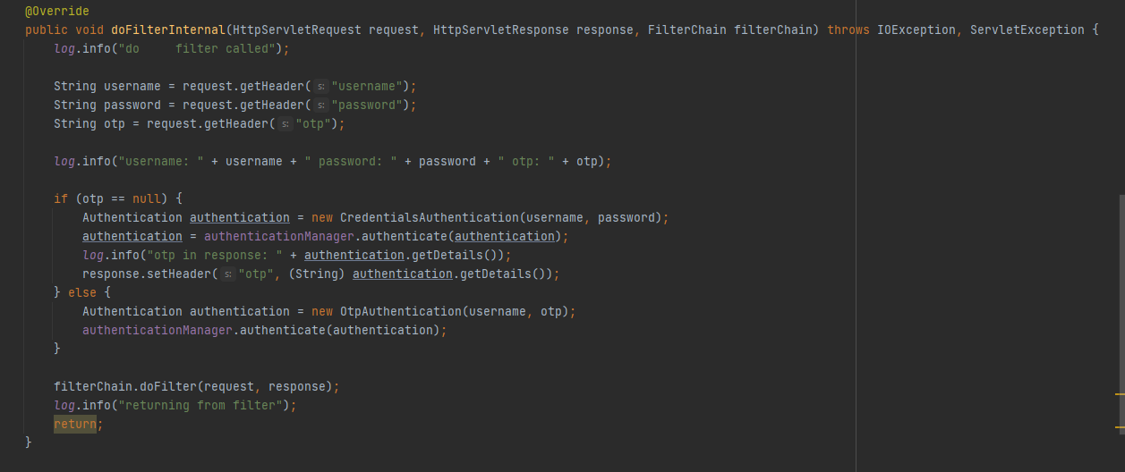

1. Postman:

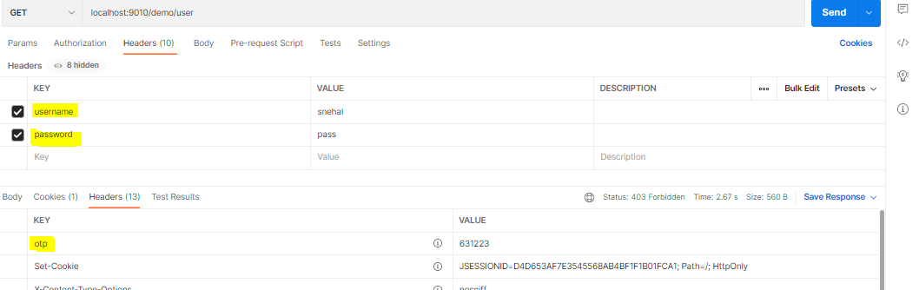

1. The otp is received in the response and also updated in the DB for that particular user.

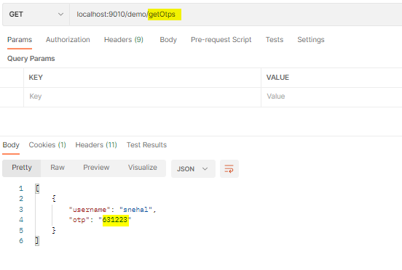

1. Next the FE will ask for otp from the user and when the user submits the otp, the backend filter will be executed again.

